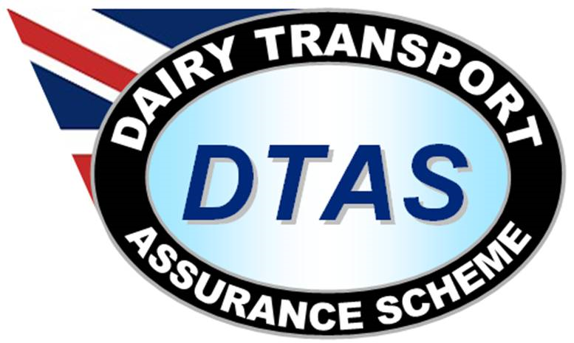

Warranty Form

This form must be completed when ever second hand barrels are purchased or when barrels are hired in for moving milk.

Name of supplier:

Address:

Identification of barrel (s):
Date of supply:

Category
Second hand purchase

Hired in barrel
Warranty Declaration

We confirm that the barrel(s) detailed above have been used for transporting food products only and have been appropriately cleaned before supplying to (insert your company name)

Details of previous 3 loads for each of the barrels identified. This is not required if new barrels have been supplied, but evidence of a pre-delivery inspection should be available.

Load 1 | Load 2 | Load 3
Date of supply | Date of supply | Date of supply
Product carried: | Product carried: | Product carried:
Date of final clean | Date of final clean | Date of final clean

Signature Name Date

For and on behalf of: (insert name of supplier)

