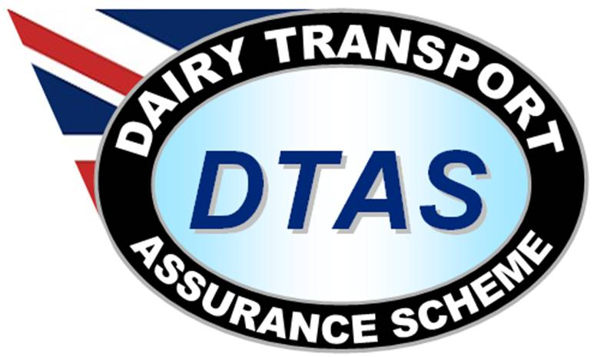
Ian Wakeling
Scheme Administrator
Dairy Transport Assurance Scheme (DTAS)
c/o Dairy UK
6th Floor
210 High Holborn
London
WC1V 7EP

Quality Assurance Questionnaire – milk tanker CIP

Dear

As a key part of the dairy supply chain the milk haulage operation has an important responsibility to ensure the milk delivered meets the highest quality standards required. Dairy UK, as owners of the Dairy Transport Assurance Scheme (DTAS), a set of national standards developed by the industry, takes this responsibility seriously.

The DTAS standards include tanker hygiene and much work has been carried out on those for tanker design, CIP operations and hygiene monitoring to ensure the highest levels can be maintained. Full details of the scheme can be found at the DTAS website at http://www.dairytransport.co.uk/ .

The tanker CIP is often carried out using 3rd party CIP sets at processing sites and it is essential that hauliers are able to access the data relating to CIP’s carried out on their tankers. This is in order to ensure that all tankers and ancillary equipment are cleaned to a satisfactory standard.

To help our members comply with the high standards of tanker cleanliness through CIP, I respectfully request that you complete the attached questionnaire and return it to me, either by post to the address shown above or by email to iwakeling@dairyuk.org .

The purpose of this request is to avoid duplication of data capture from the various haulage operators by centralising our member’s compliance with the scheme on the DTAS website.

Your assistance and support in this matter is most appreciated

Yours Sincerely

Ian Wakeling
Scheme Administrator

Quality Assurance Questionnaire

Please complete and return to the address at the top of the enclosed letter.

Company Name:
Site Address:
Completed by:
Position in Company:
Completion date:

1 | Are you familiar with Dairy UK CIP COP?
2 | Are CIP operator instructions available?
3 | Does the Operator instructions include the cleaning of ancillary equipment i.e. blank ends, filter cones, rubber seals, removable pipe work and tanker hoses?
4 | Is the CIP operated by site staff or tanker drivers?
5 | Is the unit secured when not in use?
6 | Are hose ends appropriately capped when not in use?
7 | Is the final rinse water potable?
8 | Are the chemicals in use from an approved supplier and designed for cleaning of milk tankers?
9 | Are chemicals stored securely and consistent with their data sheets?
10 | Is there provision for appropriate personal protective equipment i.e. eye wash, gloves etc? Please comment:
11 | Is the CIP maintained to a set frequency? Please comment:
12 | Is the temperature checked and recorded daily?
13 | Is the chemical concentration or conductivity checked daily and recorded?
14 | Is the flow rate /pressure checked and recorded? Please comment:
15 | Is the volume and circulation time of each CIP cycle checked, recorded and monitored? Please comment:
16 | Are all records kept for a minimum of six months?

